Open neo-gui

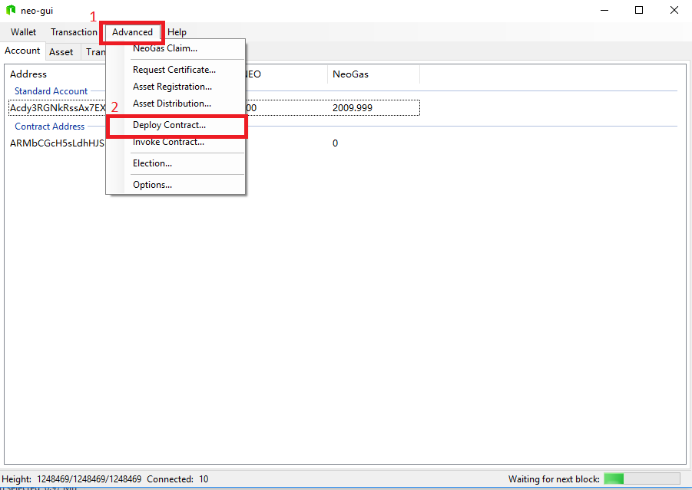

Go to “Deploy Contract interface”

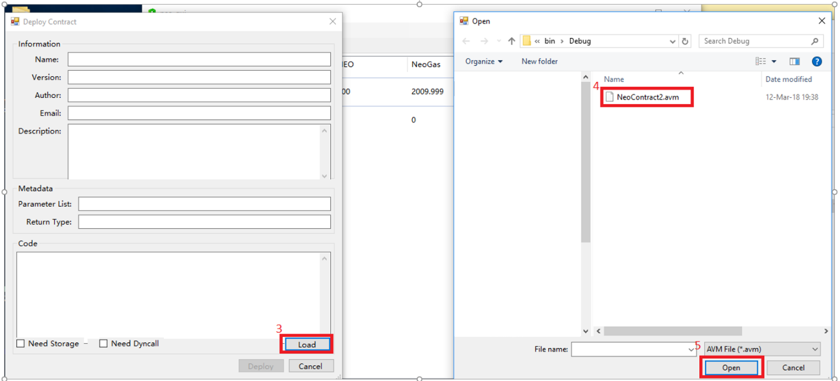

(Steps 3 to 11 are optional, as in them we check if a smart contract with this scripthash doesn’t exist already)

Load your contract

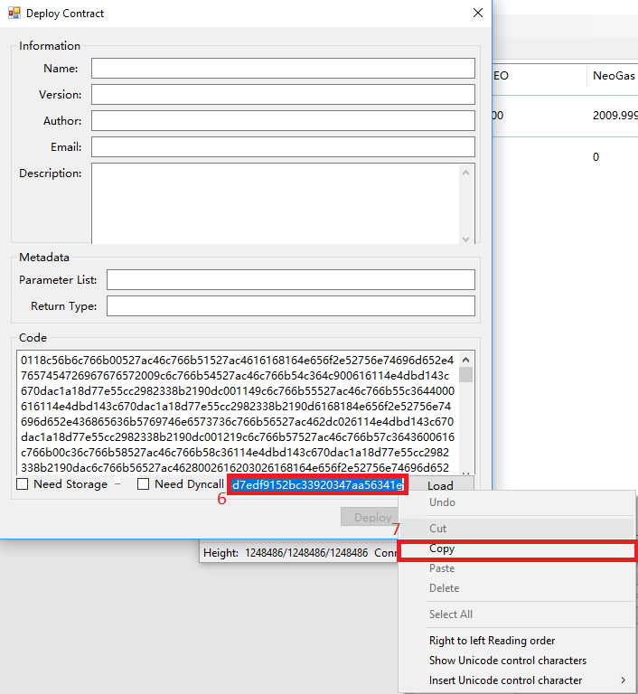

Copy contract scripthash

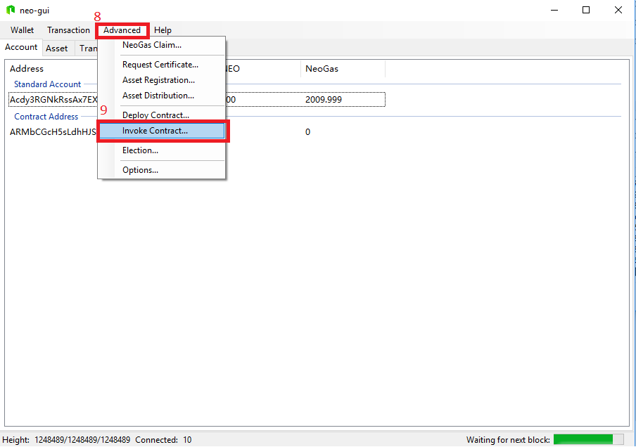

Go to “Invoke Contract” interface

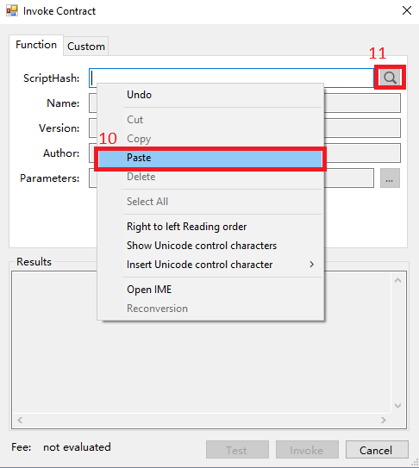

Paste your contracts scripthash and search if there isn’t already contract with a the same scripthash if **Name,Versions,Author,Parameters** fields don’t populate ,that means we are good to go

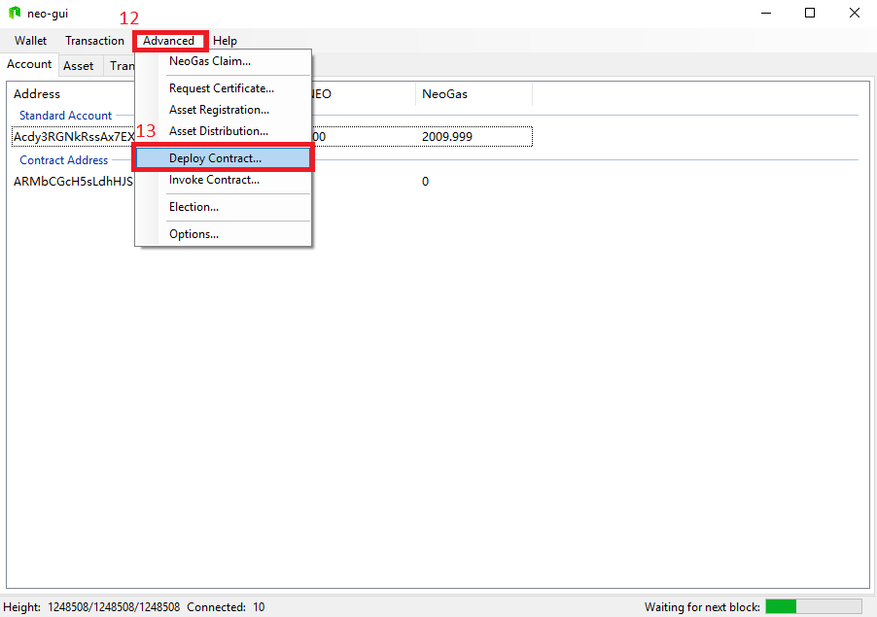

Open “Deploy Contract” interface

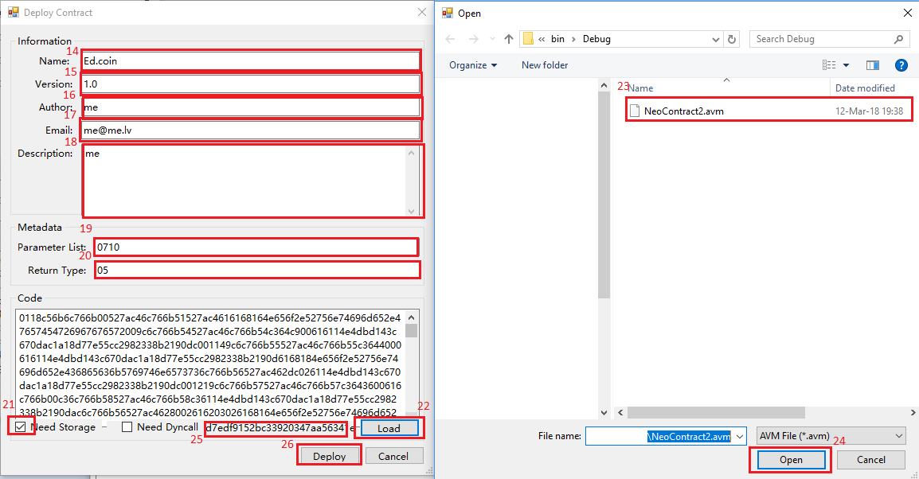

1.Fill all of the fields

2.Check Need Storage

3.Load your Contract

4.**Copy your contract scripthash** (if you forget to you can do the steps again and copy it without Deploying the smart contract)

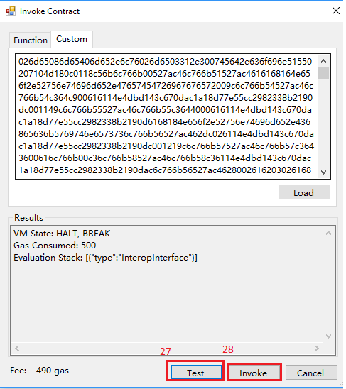

Press Test and Invoke buttons

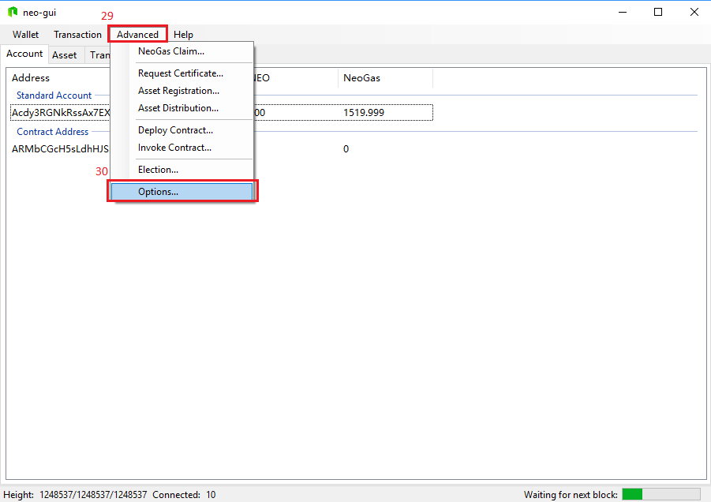

Go to Options interface

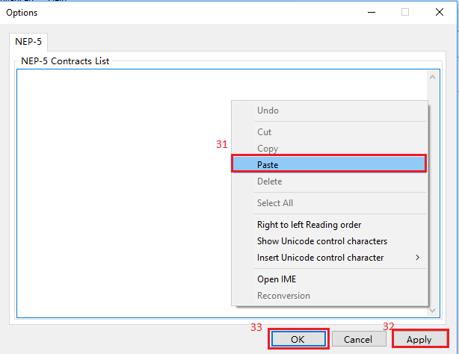

Paste your smart contract scripthash ,the press Apply and OK

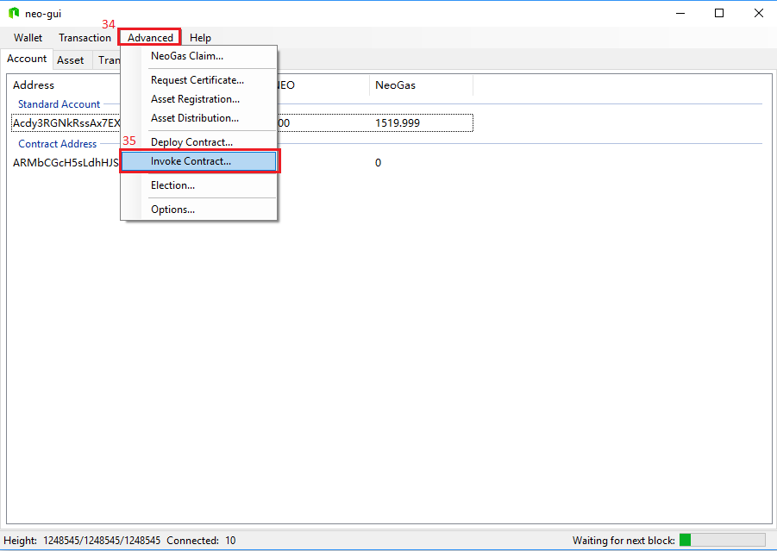

Go to “Invoke” Contract interface

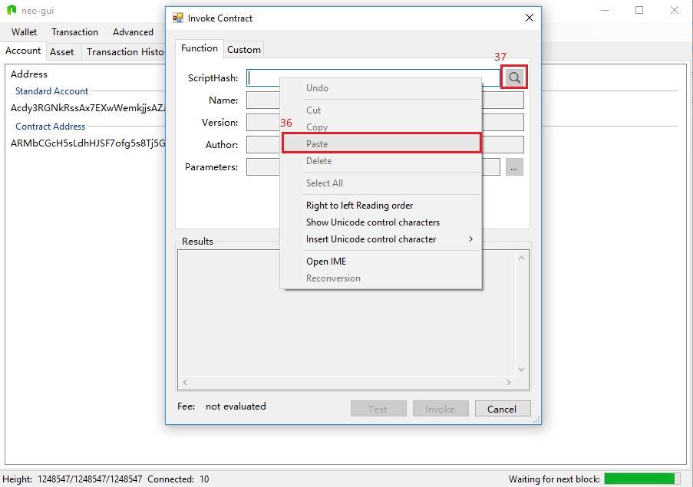

Paste your smart contracts scripthash and press search button(you may need to wait until a new block is generated for the search function to be successful)

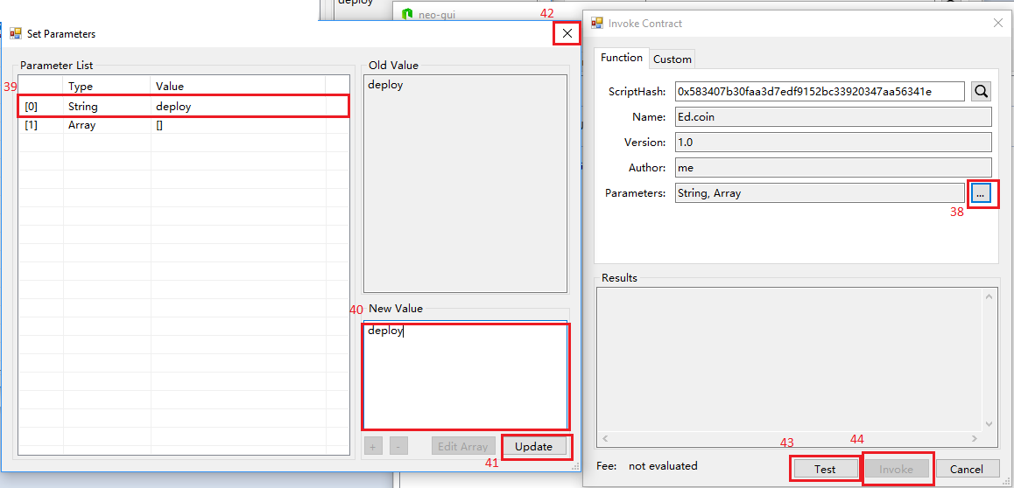

1.Add ”deploy” parameter to the invoke statement

2.Press Test and Invoke buttons.

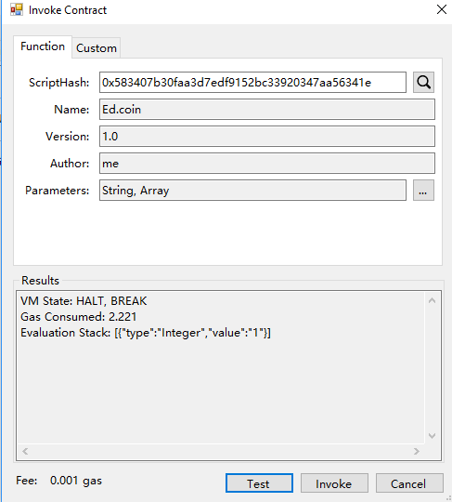

This is the response you should get.

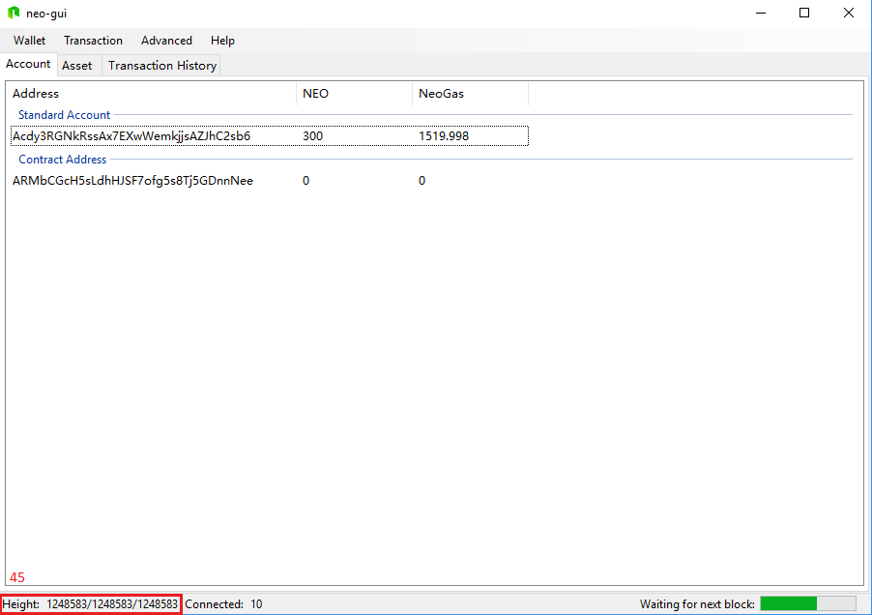

Wait until the next block generates.

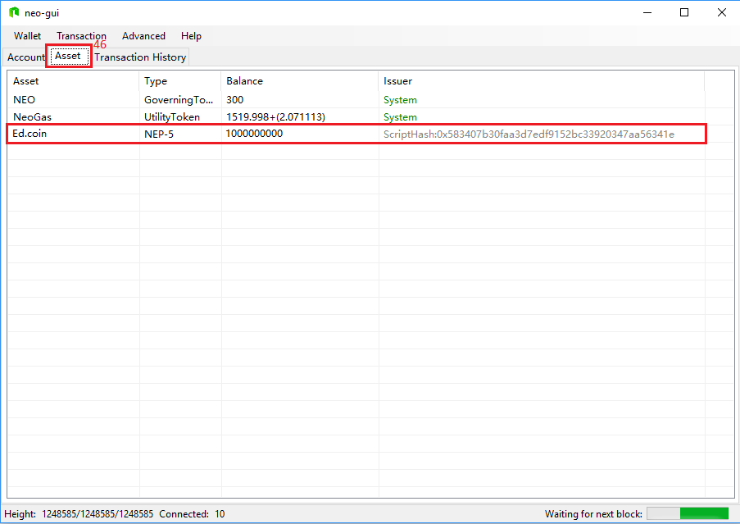

Go to “Asset” interface and you should be able to see that your tokens are in your possession.

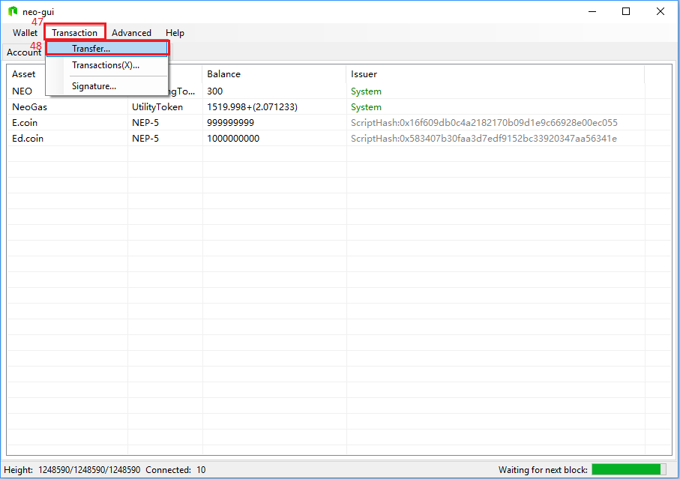

To Transfer your nep-5 tokens you need to go to “Transfer”.

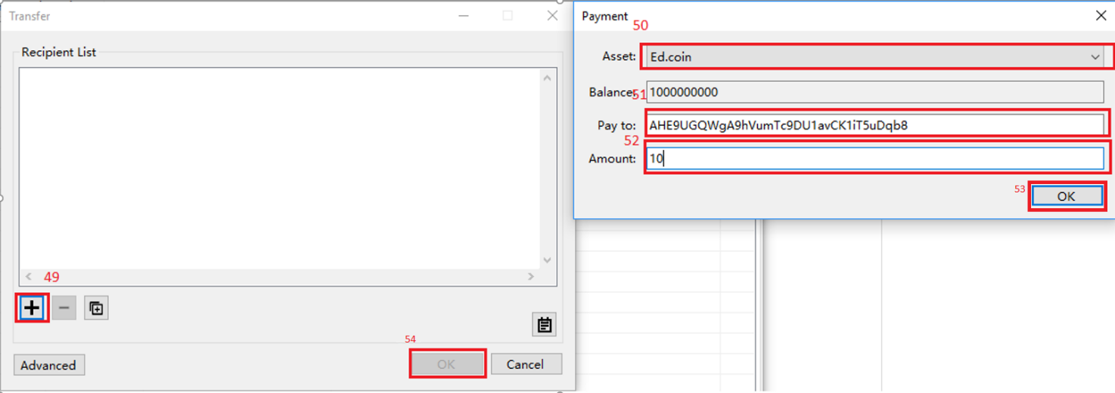

Press add button ,select which nep-5 token you wish to send ,add the recipient public address and put in the amount.Press OK and after that OK.

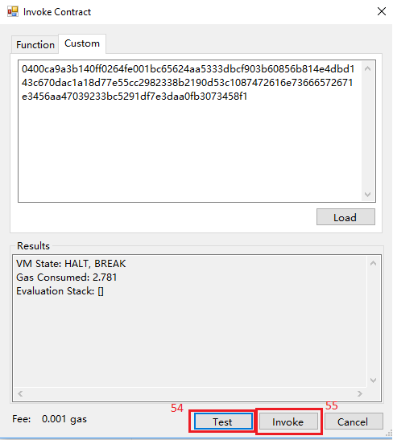

After that the “Invoke Contract” interface will pop up and you need to press Test and Invoke buttons